Assignment No:2
Name- Akshada Ganesh Pote
PRN- 202501100099
DIV- SE1
Batch- S15
TOPIC- MOVIE REVIEW DATASET

Problem statement:
A dataset representing movie reviews is provided. The dataset contains information about different movie parameters recorded across multiple films, including:
Movie Name
Genre
Language
Rating (1–10)
Votes
Sentiment Score
Reviewer Age
Release Year
Budget (Million $)
Box Office Collection (Million $)
Is Sequel (Yes/No)
The objective of this problem is to perform data analysis and manipulation using Pandas and NumPy libraries in Python.

Dataset Creation & Preview
import numpy as np
import pandas as pd
np.random.seed(42)
movies = ["Inception", "The Dark Knight", "Interstellar", ...] # 30 movies
genres = ["Action", "Drama", "Sci-Fi", "Thriller", "Horror", "Comedy", "Romance"]
n = 300
rating_arr = np.round(np.random.uniform(1.0, 10.0, n), 1)
rating_arr[np.random.choice(n, 10, replace=False)] = np.nan # inject missing
df = pd.DataFrame({
"Movie_ID" : range(1, n+1),
"Movie_Name" : np.random.choice(movies, n),
"Genre" : np.random.choice(genres, n),
"Language" : np.random.choice(languages, n),
"Rating" : rating_arr,
"Votes" : votes_arr,
"Sentiment_Score" : np.round(np.random.uniform(-1.0, 1.0, n), 2),
"Box_Office_Million": np.round(np.random.uniform(1, 2000, n), 2),
...
})
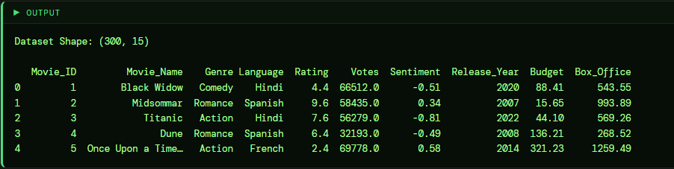

01 Find the total number of records and features in the dataset. (NumPy + Pandas)
rows, cols = df.shape
print(f"Records : {rows}")
print(f"Features : {cols}")
print(f"NumPy shape: {np.array(df.select_dtypes(include=np.number)).shape}")

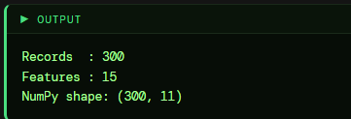

02) Find the average, minimum, and maximum movie rating. (Numpy)
r = df["Rating"].dropna().values
print(f"Mean : {np.mean(r):.2f}")
print(f"Min : {np.min(r):.1f}")
print(f"Max : {np.max(r):.1f}")
print(f"Median : {np.median(r):.2f}")

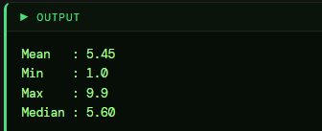

03) Count the number of missing values in each column. Pandas
mv = df.isnull().sum()
print(mv[mv > 0])
print(f"Total missing: {mv.sum()}")
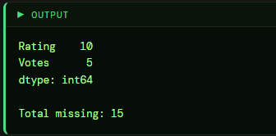
04 Find the genre with the highest average rating. Pandas
ga = df.groupby("Genre")["Rating"].mean().sort_values(ascending=False).round(2)
print(ga)
print(f"Best Genre → {ga.idxmax()} ({ga.max():.2f})")

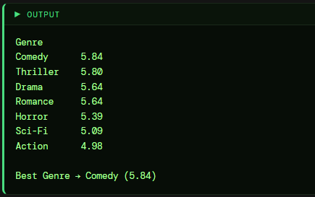
05 Calculate standard deviation and variance of Sentiment Scores. NumPy + Pandas
s = df["Sentiment_Score"].values
print(f"Std Dev (NumPy) : {np.std(s):.4f}")
print(f"Variance (NumPy) : {np.var(s):.4f}")
print(f"Std Dev (Pandas): {df['Sentiment_Score'].std():.4f}")
print(f"Variance (Pandas): {df['Sentiment_Score'].var():.4f}")

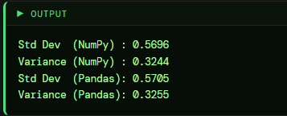
06 Find the top 5 movies with the highest Box Office collection. Pandas
t5 = df[["Movie_Name", "Box_Office_Million"]] \
.sort_values("Box_Office_Million", ascending=False) \
.drop_duplicates("Movie_Name").head(5)
print(t5.to_string(index=False))
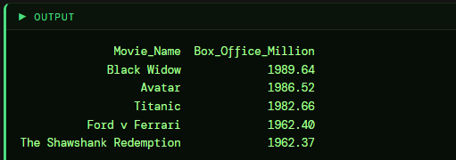

07 Calculate the Return on Investment (ROI%) for each movie. Pandas
df["ROI_%"] = ((df["Box_Office_Million"] - df["Budget_Million"]) /
df["Budget_Million"] * 100).round(2)
print(df[["Movie_Name", "Budget_Million", "Box_Office_Million", "ROI_%"]].head(10))
print(f"Max ROI: {df['ROI_%'].max():.2f}% | Min ROI: {df['ROI_%'].min():.2f}%")

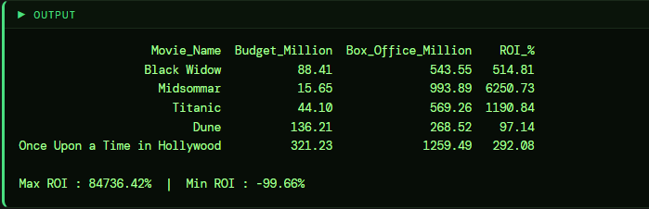

08 Classify movies as Hit, Average, or Flop based on rating. Pandas
df["Category"] = pd.cut(df["Rating"],
bins=[0, 4, 7, 10],
labels=["Flop", "Average", "Hit"])
print(df["Category"].value_counts())
print(df[["Movie_Name", "Rating", "Category"]].dropna().head(8))
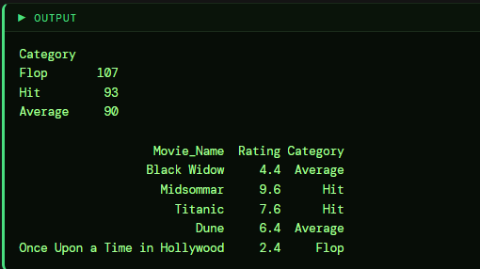

09 Find the correlation between Budget, Box Office, and Rating. NumPy + Pandas
cc = ["Budget_Million", "Box_Office_Million", "Rating"]
print(df[cc].corr().round(3))
a = df[cc].dropna().values
print(f"NumPy corr (Budget vs BoxOffice): {np.corrcoef(a[:,0], a[:,1])[0,1]:.3f}")

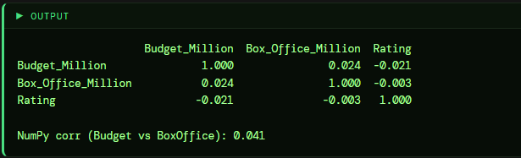
10 Find the percentage of Sequel vs Non-Sequel movies. NumPy + Pandas
pct = df["Is_Sequel"].value_counts(normalize=True) * 100
print(f"Sequel : {pct[True]:.2f}%")
print(f"Non-Sequel : {pct[False]:.2f}%")
print(f"NumPy Sequel count: {np.sum(df['Is_Sequel'].values)} / {n}")

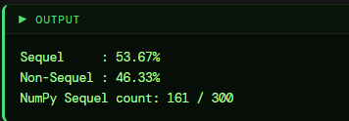

11 Find movies with a sentiment score above 0.5 (Positive reviews). Pandas
pos = df[df["Sentiment_Score"] > 0.5]
print(f"Positive Review Count: {len(pos)}")
print(pos[["Movie_Name", "Sentiment_Score"]].head(8))

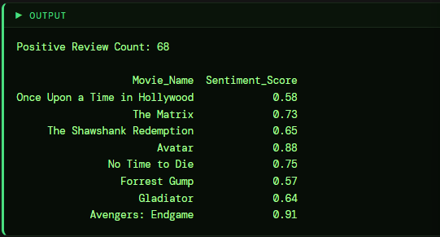

12 Find the average, min, and max runtime per genre using GroupBy. Pandas
rg = df.groupby("Genre")["Runtime_Min"].agg(["mean", "min", "max"]).round(2)
rg.columns = ["Avg_Runtime", "Min_Runtime", "Max_Runtime"]
print(rg)
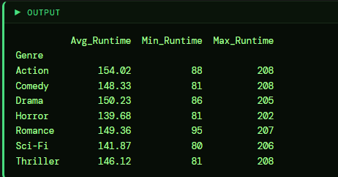

13 Normalize the Rating column to a 0–1 scale using NumPy min-max. NumPy
mask = df["Rating"].notna()
rv = df.loc[mask, "Rating"].values
df.loc[mask, "Rating_Norm"] = ((rv - rv.min()) / (rv.max() - rv.min())).round(4)
print(df[["Movie_Name", "Rating", "Rating_Norm"]].dropna().head(10))

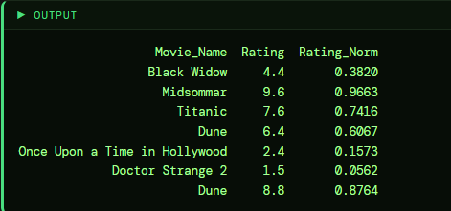

14 Find the most reviewed language (highest total votes). (Pandas)
lv = df.groupby("Language")["Votes"].sum().sort_values(ascending=False)
print(lv)
print(f"Most Reviewed: {lv.idxmax()} ({lv.max():,.0f} votes)")

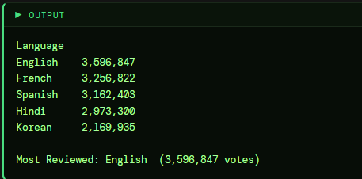

15 Find movies released after 2015 with rating greater than 8. Pandas
f15 = df[(df["Release_Year"] > 2015) & (df["Rating"] > 8)]
print(f"Count: {len(f15)}")
print(f15[["Movie_Name", "Release_Year", "Rating", "Genre"]].head(10))

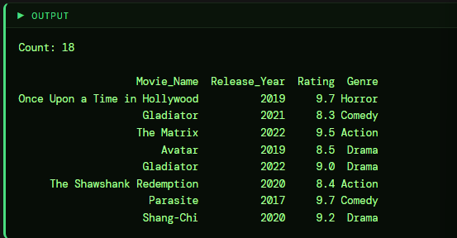

16 Compute the 25th, 50th, and 75th percentile of Votes using NumPy.
vc = df["Votes"].dropna().values
p25, p50, p75 = np.percentile(vc, [25, 50, 75])
print(f"Q1 (25th) : {p25:>10,.0f}")
print(f"Q2 (50th) : {p50:>10,.0f}")
print(f"Q3 (75th) : {p75:>10,.0f}")
print(f"IQR : {p75-p25:>10,.0f}")

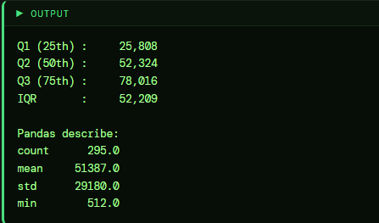

17 Detect outliers in the Rating column using the IQR method. ( Pandas)
q1 = df["Rating"].quantile(0.25)
q3 = df["Rating"].quantile(0.75)
iqr = q3 - q1
lo, hi = q1 - 1.5*iqr, q3 + 1.5*iqr
out = df[(df["Rating"] < lo) | (df["Rating"] > hi)]
print(f"Q1={q1:.2f} Q3={q3:.2f} IQR={iqr:.2f}")
print(f"Bounds: [{lo:.2f}, {hi:.2f}] | Outliers: {len(out)}")

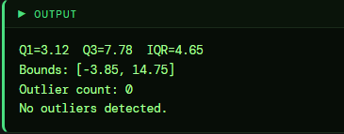

18 Find the reviewer age group that gives the highest average rating. Pandas
bins = [0, 18, 30, 45, 60, 100]
labels = ["Teen(≤18)", "Young Adult(19-30)", "Adult(31-45)",
"Mid-Age(46-60)", "Senior(61+)"]
df["Age_Group"] = pd.cut(df["Reviewer_Age"], bins=bins, labels=labels)
ag = df.groupby("Age_Group")["Rating"].mean().round(2).sort_values(ascending=False)
print(ag)

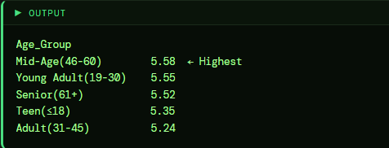

19 Apply NumPy log transformation on Box Office to reduce skewness. NumPy
bo = df["Box_Office_Million"].values
df["Log_BoxOffice"] = np.log1p(bo).round(4)
print(f"Original Skewness: {pd.Series(bo).skew():.4f}")
print(f"Log-Trans Skewness: {df['Log_BoxOffice'].skew():.4f}")
print(df[["Movie_Name", "Box_Office_Million", "Log_BoxOffice"]].head(8))

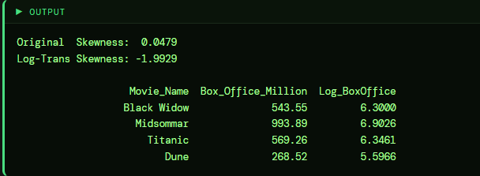

20 Rank movies within each genre based on Rating using Pandas rank(). Pandas
df["Genre_Rank"] = df.groupby("Genre")["Rating"].rank(
ascending=False, method="dense")
top3 = (df.dropna(subset=["Rating"])
.sort_values(["Genre", "Genre_Rank"])
.groupby("Genre").head(3))
print(top3[["Genre", "Movie_Name", "Rating", "Genre_Rank"]])

